Hockshi Deployment Guide on a Remote Ubuntu Server with NGINX and PM2

This guide provides detailed instructions for deploying the Hockshi application on a remote Ubuntu server using NGINX as the web server and PM2 as the process manager. The documentation is divided into two main sections: installation and configuration, and testing of the deployed application.

Part 1: installation and configuration of required packages
Hockshi is an ecommerce project that is developed with the use of node js and express , it equally uses a mariadb database , the mariadb database used is deployed in a container through docker

1.1 cloning Git repository
Before we can start with the installation process, we need to clone the git repository where our project is stored , we will clone the git repo into /var/www/html/adamaoua/batouri/

- Navigate to /var/www/html/adamaoua/batouri/ :
Execute: cd /var/www/html/adamaoua/batouri/
- Install git
Execute : sudo apt upgrade
Sudo apt install git
- clone repository
Execute : git clone -b "admin_dashboard" https://gitlab.hockshi.com/hockshi.git

- Navigate into the repository
Execute : cd hockshi

1.2 installing packages
The packages used to successfully deploy this application are node , npm , nginx, docker and pm2

- Node: node or node.js is our runtime environment that will execute our application code
- NPM: NPM or node package manager helps in installing and managing third-party dependencies that are needed by our application
- PM2: PM2 or Process manager helps in managing node.js processes , it ensures that processes are always running , if our node process crashes for any reason , pm2 will automatically restart it
- Docker: docker will be used to run a container with mariadb for our application database
- Nginx: nginx is a web server that handles requests but in our case , we will use nginx as a reverse proxy that will redirect requests to our node app
- Mysql-client: mysql-client will give us the possibility to connect to our mariadb server and execute commands

Execute : sudo apt install node npm docker.io nginx mysql-client
Execute: sudo systemctl start docker

Execute: sudo systemctl enable docker

1.3 setting up our database
As said earlier, our application uses docker to run a mariadb container

1.3.1 installing a mariadb container
Execute: sudo docker run -p 3306:3306 -d --name mariadb -e MYSQL_DATABASE=hockshi -e MARIADB_ROOT_PASSWORD=Password123! Mariadb
Explanation:
- sudo docker run: Runs a Docker container.
- -p 3306:3306: Maps port 3306 on the host to port 3306 in the container, allowing external access to the MariaDB server.
- -d: Run the container in detached mode (in the background).
- --name mariadb: Assign the name "mariadb" to the container.
- -e MYSQL_DATABASE=hockshi: Sets an environment variable inside the container to create a database named "hockshi".
- -e MARIADB_ROOT_PASSWORD=Password123!: Sets the root password for the MariaDB server.
- mariadb: Specifies the Docker image to use (MariaDB).

In summary , this command will runs a mariadb server in a docker container, accessible on port 3306, with a database named “hockshi” and the root password “Password123!” , if the mariadb image is not found locally , docker will automatically pull it for you

1.3.2 connecting to our mariadb server
Before we can connect , we need to verify the host IP address on which our mariadb server is running, it may likely be 172.17.0.2 or 127.0.0.1 or something else , to verify the host on which mariadb is running we can use;

Execute:sudo docker inspect mariadb

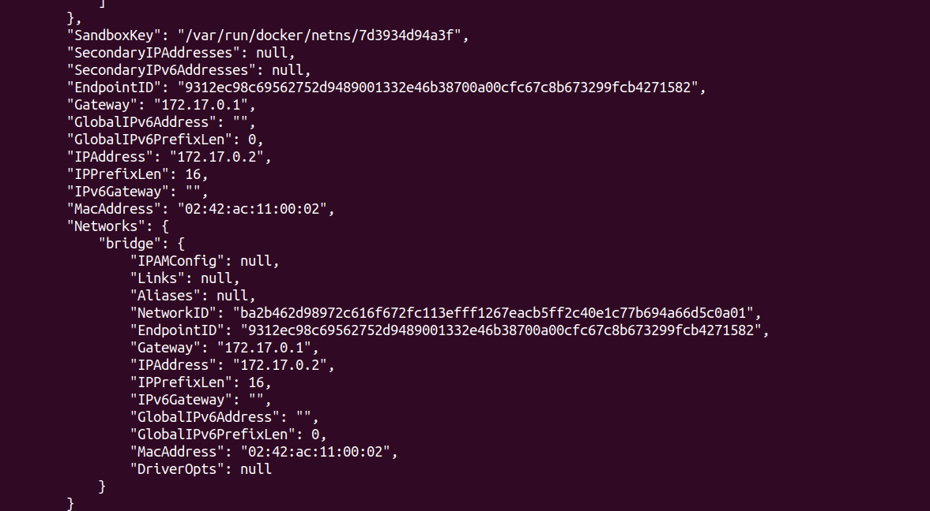
The host IPAddress can be found in the Networks section

Once we have verified the host IP address, we can connect to our mariadb server with this command;

Execute: mysql -h 172.17.0.2 -P 3306 -u root -p < database/sql/hockshidb.sql

This command will connect to our database server and run the commands found in hockshidb.sql.

hockshidb.sql contains commands to create all the tables with some predefined data that our application needs , you can equally decide to run these commands manually by omitting /database/hockshi.sq to the command , the command will look like this
mysql -h 172.17.0.2 -P 3306 -u root -p , this command will log you into the mariadb server as the root user

Note: if your host is not 172.17.0.2 , you should change it to the host you received when executing “ docker inspect mariadb”

1.4 creating .env file
our app makes use of some information that are stored in a .env file , if this file is not created and the required environment variables are not registered , the deployed app will crash

Execute : sudo nano .env

This will create a new file called .env and the file will automatically be opened with nano, inside the .env file , paste these environment variables

TEST_PORT=5445
PRODUCTION_SITE_PORT=3000
ROOT_PATH=""
DB_PSWD="Password123!"
DB_USER="root"
DB_NAME="hockshi"
DB_HOST="172.17.0.2"
HOST="https://stage.hockshi.com"
NODE_ENV=""

EMAIL_USER="your email address @gmail.com"
EMAIL_PASS="your application passcode"

SESSION_MAXIMUM_TIME_IN_MILLI_SECONDS=259200000

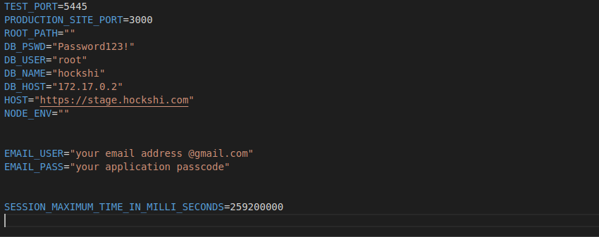

- ROOT_PATH :
It contains the path to the root directory , initially it is set to an empty string and when the program will be executed
process.env.ROOT_PATH=path.join(__dirname, './');

This line of code will set the process.env.ROOT_PATH to whatever the root directory is
- DATABASE CONFIGURATIONS (DB_PSWD,DB_USER,DB_NAME_DB_HOST)
These environment variables store the information used by our program to connect to our database.
Note : DB_PSWD is the password used to login to our database
- EMAIL CONFIGURATIONS(EMAIL_USER,EMAIL_PASS)
These variables store information used by nodemailer (the js library used to send mails) to send mails. The EMAIL_PASS contains the app password that you will register at

https://support.google.com/accounts/answer/185833?hl=en

An app password is a 16-digit passcode that gives a less secure app or device permission to access your Google Account. App passwords can only be used with accounts that have 2-Step Verification turned on.
- SESSION_MAXIMUM_TIME_IN_MILLI_SECONDS
This variable contains the maximum lifespan of a cookie in milliseconds

1.4 installing required dependencies
In this phase , we will install all the dependencies required by our app and we will equally tun the app with pm2

Execute: npm install
This command will make use of the package.json file , more precisely the dependencies and dev-dependencies attributes to install all these dependencies at once

1.4.2 installing pm2
As said earlier pm2 will enable use to run and manage our node app in case it crashes

Execute : npm install pm2 -g
Execute : sudo pm2 start server.js --name hockshi

Explanation
- The first command will install pm2 globally , making it available by any directory
- The second command will start our node app, it works like npm run dev

Note: if we make any change to our project , we need to restart our pm2 process , we can do so by executing pm2 restart hockshi

1.5 configuring nginx
In this phase of deployment, we are going to configure nginx as a proxy server , that will redirect requests to our node application

Execute : sudo nano /etc/nginx/sites-available/hockshi

This command will create a file called hockshi in /etc/nginx/sites-available , the newly created file is a configuration file that will enable use to set rules to define how nginx should process requests to our app

After creating , it will automatically opened the file with nano

Inside the newly created file, paste these commands

server {
listen 80;
server_name stage.hockshi.com;

location / {
proxy_pass http://localhost:3000;
proxy_http_version 1.1;
proxy_set_header Upgrade $http_upgrade;
proxy_set_header Connection 'upgrade';
proxy_set_header Host $host;
proxy_cache_bypass $http_upgrade;
}
}

Explanation:

- Server block: Defines the configuration for a specific virtual server.
- listen 80;
Tells Nginx to listen on port 80, the standard port for HTTP traffic.
- server_name stage.hockshi.com;
Specifies the domain name for this server configuration. Requests to stage.hockshi.com will be handled by this block.
- location / { ... } block
Defines how to handle requests for the root URL (/) and its sub-paths.
- proxy_pass http://localhost:3000;
Forwards (proxies) all requests to the server running on http://localhost:3000. This is where your Node.js application is assumed to be running.
- proxy_http_version 1.1;
Uses HTTP/1.1 for the proxied requests. Necessary for WebSocket support and other features.
- proxy_set_header Upgrade $http_upgrade;
Passes the Upgrade header from the client to the proxied server, necessary for WebSocket connections.
- proxy_set_header Connection 'upgrade';
Ensures the Connection header is set to 'upgrade', necessary for WebSocket connections.
- proxy_set_header Host $host;
Passes the original Host header from the client request to the proxied server. This is important for virtual hosting setups.
- proxy_cache_bypass $http_upgrade;
Ensures that WebSocket connections are not cached.

Summary
This Nginx configuration sets up a reverse proxy:
- It listens on port 80 for HTTP requests to stage.hockshi.com.
- Forwards all these requests to a Node.js application running on localhost:3000.
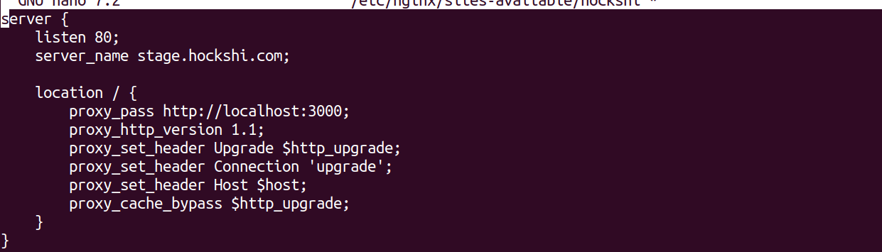
Note: do not forget to save (ctrl + s) before exiting the editor (ctrl + x)
Once we have saved and exited the text editor , we need to create a symbolic link to enable it
Execute: sudo ln -s /etc/nginx/sites-available/hockshi /etc/nginx/sites-enabled/
After all of this is done we can test our new configurations with sudo nginx -t and reload out server with sudo systemctl reload nginx
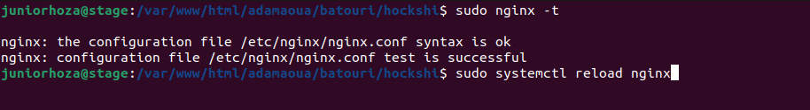

1.5.2 Enabling SSL/TLS for our domain with letsencrypt
To enable ssl/tls with let's encrypt, we need to install certbot which is a package from letsencrypt which enables us to obtain SSL/TLS certificates from letsencrypt

Execute: sudo apt install certbot python3-certbot-nginx
Once certbot has been installed, we can use it to obtain a certificate for our domain by using this command

Execute: sudo certbot --nginx -d stage.hockshi.com

Once your SSL/TLS certificate has been successfully established , you will receive a message that looks like this

IMPORTANT NOTES:
Successfully received certificate.
Certificate is saved at: /etc/letsencrypt/live/stage.hocshi.com/fullchain.pem
Key is saved at: /etc/letsencrypt/live/stage.hocshi.com/privkey.pem
This certificate expires on 2022-06-01.
These files will be updated when the certificate renews.
Certbot has set up a scheduled task to automatically renew this certificate in the background.

- - - - - - - - - - - - - - - - - - - - - - - - - - - - - - - - - - - - - - - -
If you like Certbot, please consider supporting our work by:
* Donating to ISRG / Let's Encrypt: https://letsencrypt.org/donate
* Donating to EFF: https://eff.org/donate-le

1.5.3 Updating our Nginx site configuration
After our SSL/TLS certificate has been successfully approved, we need to modify our nginx configuration file we created earlier

Execute : sudo nano /etc/nginx/sites-available/hockshi
This command will open our configuration file. Once this file is opened, we can replace the old configurations with these new configurations

server {
listen 443 ssl;
server_name 159.65.113.91;

ssl_certificate /etc/letsencrypt/live/stage.hockshi.com/fullchain.pem;
ssl_certificate_key /etc/letsencrypt/live/stage.hockshi.com/privkey.pem;

location / {
proxy_pass http://localhost:3000;
proxy_http_version 1.1;
proxy_set_header Upgrade $http_upgrade;
proxy_set_header Connection 'upgrade';
proxy_set_header Host $host;
proxy_cache_bypass $http_upgrade;
}

}
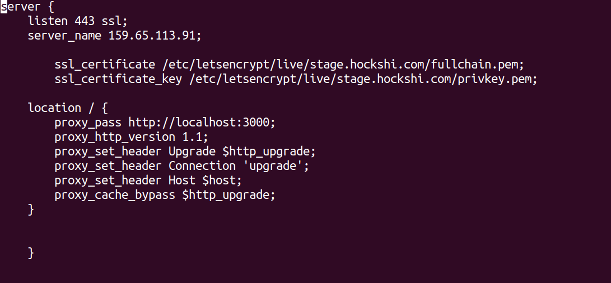

Explanation:
- listen 443 ssl;: This tells Nginx to listen for incoming connections on port 443, which is the standard port for HTTPS traffic, and to use SSL/TLS for encrypting the connections.
- server_name 159.65.113.91;: This sets the server name for the virtual server. It can be an IP address or a domain name. In this case, it’s an IP address.
- ssl_certificate /etc/letsencrypt/live/stage.hockshi.com/fullchain.pem;: This specifies the path to the SSL certificate file. The fullchain.pem file contains the server certificate as well as any intermediate certificates.
- ssl_certificate_key /etc/letsencrypt/live/stage.hockshi.com/privkey.pem;: This specifies the path to the private key file corresponding to the SSL certificate.
- proxy_pass http://localhost:3000;: This directive tells Nginx to forward (proxy) requests to the server running on localhost at port 3000. This is typically your Node.js application.
- proxy_http_version 1.1;: This sets the HTTP version to 1.1 for the proxied connection. HTTP/1.1 supports features like keep-alive and chunked transfer encoding.
- proxy_set_header Upgrade $http_upgrade;: This sets the Upgrade header from the client request to the proxied request. This is often used for WebSocket connections.
- proxy_set_header Connection 'upgrade';: This sets the Connection header to upgrade, which is necessary for WebSocket connections.
- proxy_set_header Host $host;: This sets the Host header in the proxied request to the value of the $host variable, which is the domain name of the request. This ensures that the backend server receives the correct Host header.
- proxy_cache_bypass $http_upgrade;: This directive prevents the caching of WebSocket connections by bypassing the cache if the Upgrade header is set.

Summary
This Nginx configuration is set up to:
- Listen for HTTPS connections on port 443.
- Use SSL/TLS certificates from Let’s Encrypt.
- Proxy incoming requests to a Node.js application running on localhost at port 3000.
Note: do not forget to save (ctrl + s) before exiting the editor (ctrl + x)
After all of this is done we can test our new configurations with sudo nginx -t and reload out server with sudo systemctl reload nginx


Part 2 : Testing our Application
After completing the installation and configuration, it's essential to verify that the Hockshi application is running correctly.

Access the Application
- Open a Web Browser: Launch any modern web browser of your choice (e.g., Google Chrome, Mozilla Firefox, Microsoft Edge).
- Navigate to the Application Endpoint: In the browser’s address bar, enter the following URL to access the admin section of the Hockshi application:
https://stage.hockshi.com/admin

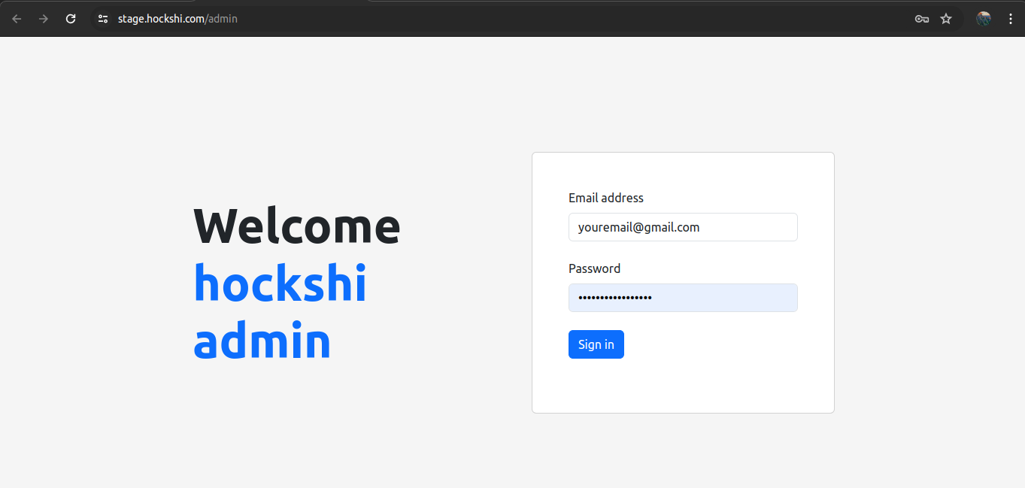

If all the configurations were done correctly , you will receive this login page

By following this guide, you have successfully deployed the Hockshi application on a remote Ubuntu server using NGINX and PM2. Ensure regular maintenance and monitoring of the server to maintain optimal performance and security. For any issues or further customization, refer to the official documentation of Node.js, NGINX, and PM2.

Thank you for reading this documentation I hope it helped you in deploying your application

